**Employee Management System**

* What is this System?

This employee management system created by r/programmerhumour is designed to simplify the process of record maintenance of employees in an organisation and modernize the old pen and paper style system of data management. This system can be used in managing the information of employees for HR functions and can be implemented in practically any business environment, as it’s unique design allows easy collaboration and adaptation to easily manage and maintain employee data and business records. In general, this software can be used as a form of comprehensive Human Resource Management System software.

* What does this System do?

This essential goal of this system is to manage your employees and perform tasks that are essential for a healthy work/business environment. Tasks such as tracking employee hiring dates, sick leave dates, disability status, viewing records of employee complaints to address and even employment status have never been easier with this software. The simplistic yet effective layout of the User Interface provided allows for seamless interaction and collaboration with the database (using SQL and database manipulation techniques in the background) while ensuring that you have the ease of access to your data all in one location.

* What pre-requisites are needed to use this software?

Users interacting with our software need only have a basic understanding of how to use a computer and be familiar with using computer programs or any software in general to be able to interact with this system. But because our software has been designed to be very user friendly and offer a simple interaction yet effective result, navigation and mastering the controls of this software will be a easily obtained skill after a few uses.

* Constraints of this software

The following criteria are required for the program to run correctly:

* Program is only compatible with the Windows environment.
* Systems running this software must have a minimum of 4GB RAM
* Systems must have .NET 4.5 package installed
* 5GB of free HDD space

*Optional: For best results, systems running this software should have a 4th generation Pentium processor or better. (AMD equivalent: Athlon x2 or better)

**Screenshots of what this software’s UI looks like:**

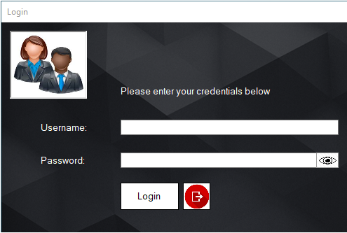

Figure - Login Menu

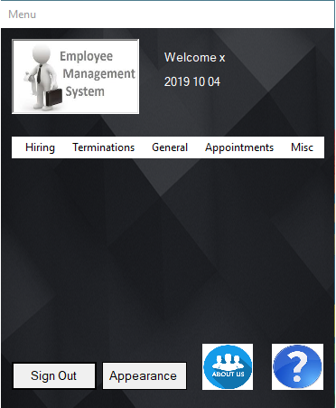



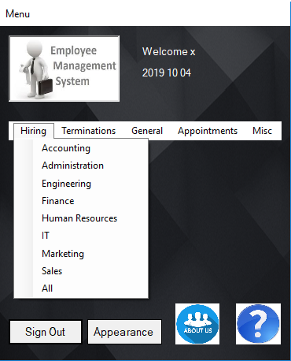

Figure - Home Screen Menu

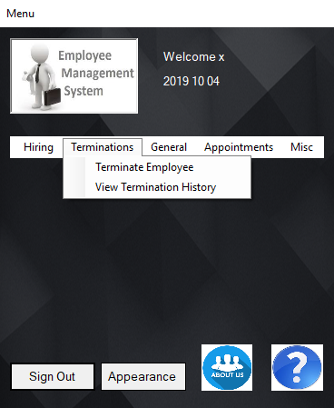

Figure - Home Screen Menu2

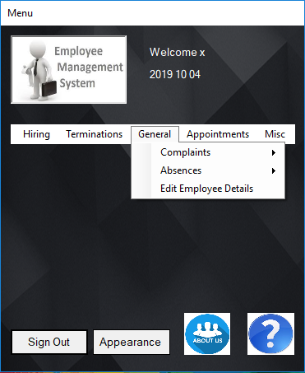

Figure - Home Screen Menu3

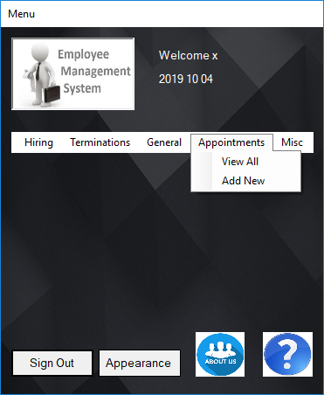

Figure - Home Screen Menu4

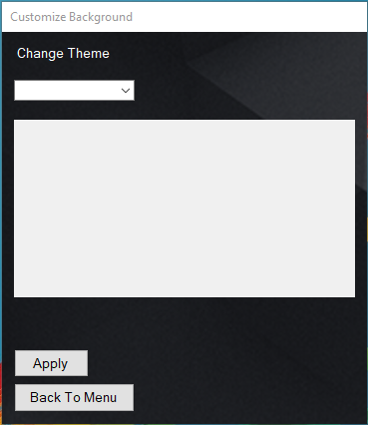

Figure - Change Appearance Screen

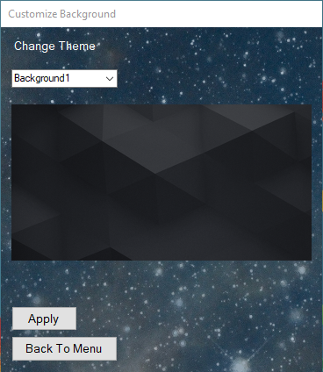

Figure - Change Appearance Screen2

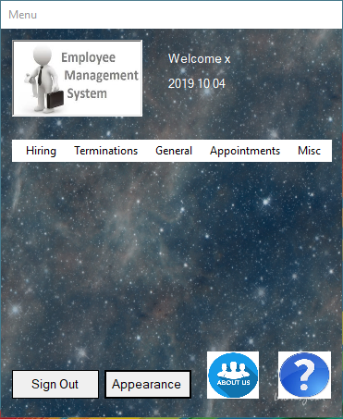

Figure - Changed Appearance Home Screen

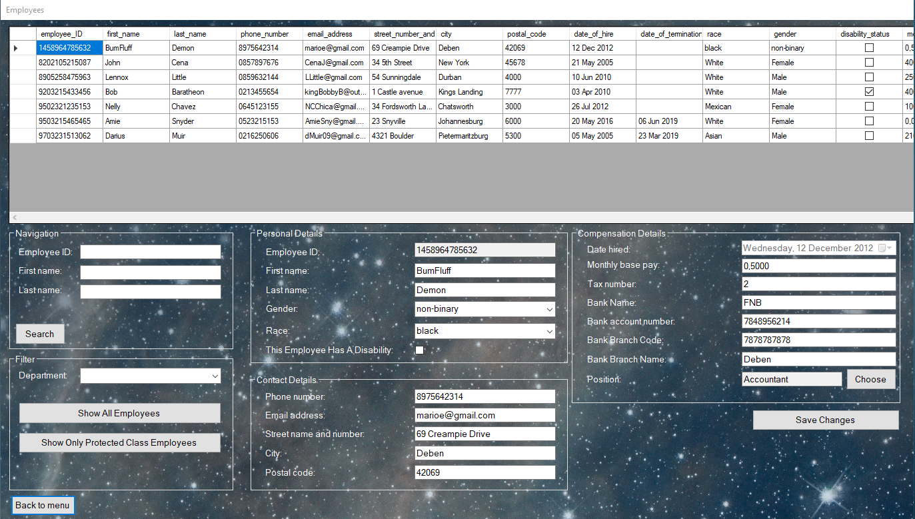

Figure - Employees Form

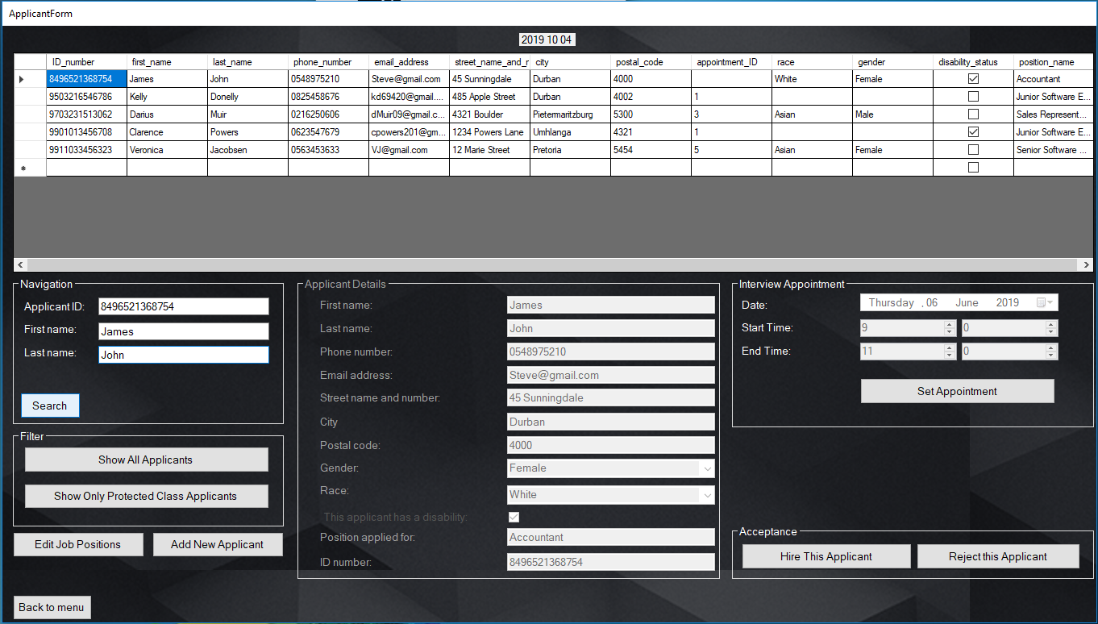

Figure 10- Applicant Form

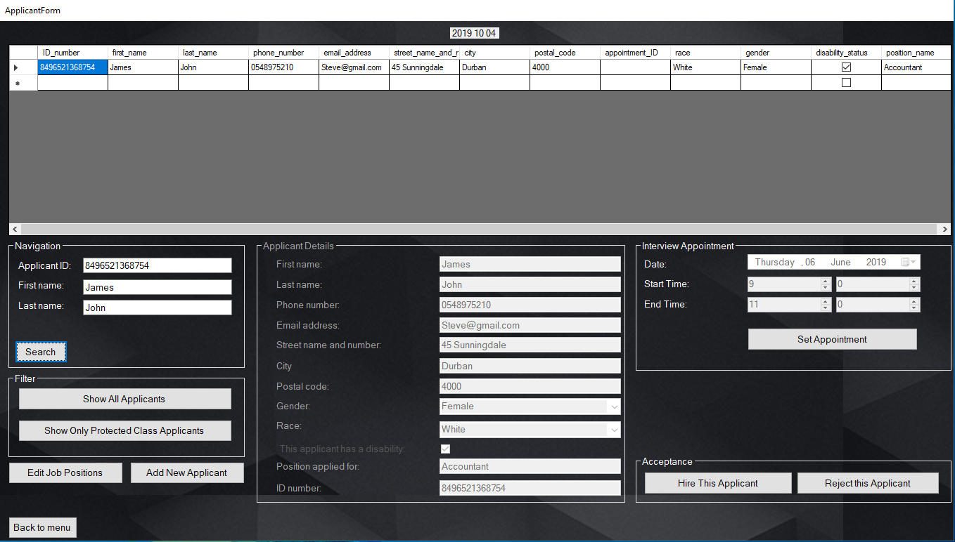

Figure - Applicant Form2

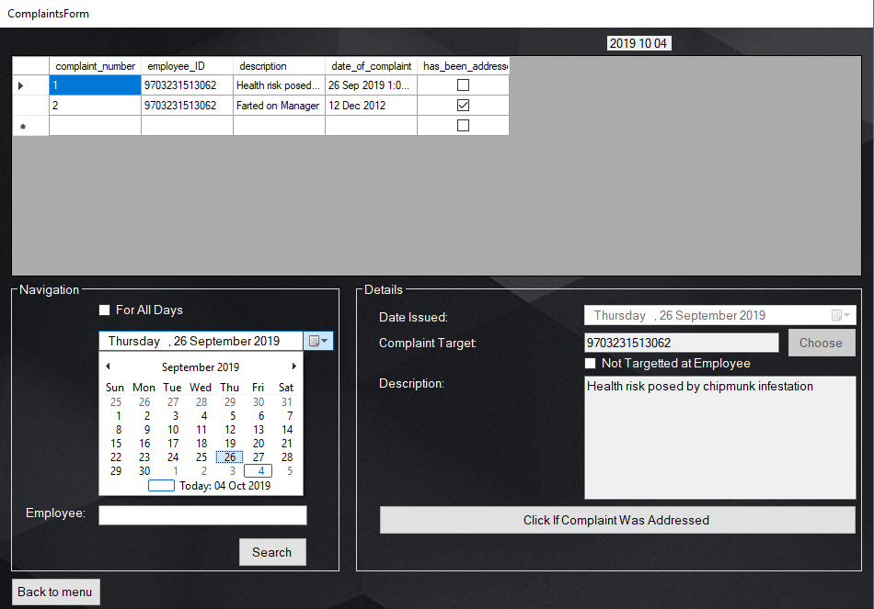

Figure -Complaints Form



Figure - Complaints Form2

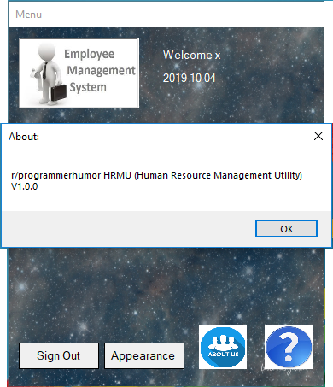

Figure - About Form

**SQL QUERIES USED IN THIS SOFTWARE**

//selects only active employees: for adding to appointments, editing details, filing complaints

Select *-employee_status from employee where employee_status = active

//select all applicants by department

Select * from applicant where position_ID in(select position_ID from position where department = @dept)

HIRING PROCESSES:

//adding an applicant

If exists(select * from applicant where ID = @id)

Begin

Update applicant set

Phone_num = @phoneNum

Email = @email

Street_det = @street

City = @city

Post_code = @post_code

Disability_status = @disability

Resume = @resume

Where ID = @id

End

Else

Begin

Insert into applicant values(@id, @Fname, @Lname, @........)

End

//add a resume to an applicant

Update applicant set resume = @resume

Where ID = @id

//attach an appointment to an applicant

Update applicant set appointment_ID = @aptID

Where ID = @id

//delete an applicant

Delete from applicant where ID = @id

//hire an employee

If exists(select * from employee where EmployeeID = @applicant_id)

Begin

Update employee set

Salary = @salary

Position = @position

…….

Where ID = @id

End

Else

Begin

Insert into employee values(@id, @Fname, @Lname, @........);

Update employee set

Salary = @salary

……

End

Update position set (num_available = num_available – 1) where positionID = @position

TERMINATION PROCESSES:

//select only terminated employees for termination history

Select* from employee where not employee_status= active

//terminate an employee

//remove them from appointments

Delete from appt_guest where Employee_ID = @id

//change employed status

Update employee set

Employee_status = @terminationType

Termination_date = @terminationdate

Where employee_ID = @id

//delete terminated employees

Delete from complaints where employee_ID in (select employee_ID from employee where not employee_status = active);

Update payments set employee_ID = NULL

Where employee_ID in (select employee_ID from employee where not employee_status = active);//unless we remove the payments table

Delete from employee where not employee_status = active;

APPOINTMENTS

//add new appointment: one use is when setting the interview appointment for an applicant.this will execute just before the “//attach an appointment to an applicant” code

>check that the input times do not coincide with existing appointments

Insert into appointment values(……)

>go to employee table,filtered to only show id,fname,lname , and only for active employees.

>on btn add_to_appt click:

Insert into appt_guest values @EntryNum,@appt_ID,@employee_ID

>send emails

//change appt details

> go to appointments form

>when user clicks an appointment, changes details and clicks done:

Update appointment set start_date = @startDate, end_date = @endDate where appointment_number = @aptNum

>if the user clicks remove guest button, go to a reduced employee form:

Select ID,fname,lname from employee where ID in (select employee_ID from appt_guest where appointment_number = @aptNum)

>when the user clicks an employee and clicks the uninvite button:

Select email from employee where ID = @ID

>add these to an array UNINVITED

Delete from appt_guest where appointment_number = @aptNum AND employee_ID = @ID

>when the user clicks the done button go to the appointment form

>if the user clicks add guest button, go to a reduced employee form:

Select ID,fname,lname from employee where not ID in (select employee_ID from appt_guest where appointment_number = @aptNum)

>when the user clicks an employee and clicks the invite button:

Insert into appt_guest values (@entryNum, @aptNum, @ID)

>when the user clicks the done button go to the appointment form

>send update notices

Select email from employee where employee_ID in(select employee_ID from appt_guest where appointment_number = @aptNum)

>for each row: sendEmail(hrEmail,row.emailValue,”Change of Appointment details”, “You are hereby informed of the following change: the appointment previously scheduled for dateOLD at starttimeOLD to endtimeOLD has been rescheduled to dateNEW at starttimeNEW to endtimeNEW”)

>for each email in UNINVITED: sendEmail(hrEmail,uninvited.emailValue,”Change of Appointment details”, “You are hereby informed of the following change: you are no longer scheduled for an appointment on dateOLD starttimeOLD to endtimeOLD”)